


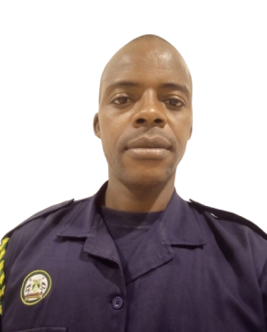
Daniel
Kyalo Muli
0717 102 147
Danielkyalo3@gmail.com
Nairobi, Kenya

EXPERIENCE
01/2023-12/2024
Customer services
Essential services & security details

01/2020-12/2024
Constable/ Team Doctor
Nairobi City County Government

01/2015-12/2016
Joy cyber & computer services
2018-2019
01/2014-12/2015
2018-2020
Tayo Road Construction
Supervisor
Nairobi East Sub-County Team Leader
Nairobi County Youth Network
01/2008-12/2009
Football Coach
Mathare Youth Sports Association

EDUCATION
09/2023
Alison College
Period Sept 2023
Certificate in security management

06/2007
Mathare Youth Sports Association
Period 2007 June
Football coach certificate
05/2013
Wright Flyers International College
Computer packages certificate

Alison College
Period 2022-2024
Diploma in environment
Home study college
2021-2023 Diploma In Project Management

Bethlehem Sec School
Period 2000-2004
Kenya Certificate of Secondary Education (KCSE)

Bethlehem Primary School (KCPE)
Period 1993-2000

SUMMARY
Positive and upbeat customer service specialist bringing 1 ½ years of customer-facing experience in fast paced settings. Highly adaptable to addressing diverse customer needs. Proven history of building trust with customers to promote satisfaction, resolve concerns and maintain long-term loyalty.

SKILLS
- Records management
- Decision-making

PERSONAL INFORMATION
Date Of Birth:04/24/1986
Gender:Male
Nationalit:Kenyan
Marital Status:Married
Religion:Christian

REFERENCES
- Johnstone Kamau
Joy Cyber
0724 236 988
- Simon Nyamakara
Wright Flyers College
0203504658
- James Njoroge
In Charge Of Security
Task Force
0711 918 523

HOBBIES AND INTERESTS
- Playing football and watching
- Comedy
- Travelling

