CURRICULUMVITAE
NAME: MOSEOBAREVINCENT
GENDER: MALE
NATIONALITY: KENYAN
MOBILENO. 0728559966/+97430669761
Email:
vinnyobare1986@gmail.comP OSTAL ADDRESS: P.O.Box2755–40200KISII. LANGUAGE: KISWAHILIANDENGLISH EDUCATION BACKGROUND
January–March,2020:UnikDrivingSchool
DrivingLicense(CategoryC1,LightTruck)
May,2013–Nov,2021:BachelorofTechnologyinAppliedChemistry.
Technical UniversityofMombasa
Nov,2008–Dec,2008:CertificateinFirstAidAdministrationSkills
St. JohnAmbulance
Jan,2006–May,2006:CertificateinComputerApplication
St.Ann‘sComputerCollege
Jan,2002–Nov,2005:KenyaCertificateofSecondaryEducation
St.Luke’sEkwareSecondarySchool
Jan,1990–Nov,1998:KenyaCertificateofPrimaryEducation
St.Joseph’sPrimarySchool

SKILLSANDACHIEVEMENTS
- Highlevelofinterpersonalandcommunicationskills fosteredfromworking inteams during my tertiary education and various working experience.
- Teamoriented,professional,eager andwillingto leadandworkcollaborativelywith colleagues to successfully achieve goals and expectations.
- Competentincomputerskills.
- Reliableanddependable withhighpersonalstandardsand attentionto details.
- Abilityto adoptnewworkingenvironments,meet deadlinesandworkunderpressure with minimal supervision. Basic knowledge in database construction and data entry.

WORKINGEXPERIENCE
17FEB2023TODATE:Working asahelperinaCartonFactoryinDoha,Qatar(Arabian
Packaging)on contra t that ended on Feb17 2025 2021TO17FEB2023:WorkingasastandbydriveratScalingJunior AcademyinKisiiTownship. Jan, 2013 – May, 2013: Coca Cola Company, Kisii
Position :AssistantLaboratoryTechnician May, 2009 – Aug, 2009: WakenyaPamoja Sacco Society Position M – Pesa Attendant or Teller Jan2009-May,2009:Mozamad Bookshop and Stationery
Position :QuickBooks–PreparationofDeliveryand InvoicesforCustomers
Jun,2006–Dec,2006:Living WaterResourcesCyberCafé
Position :CyberAttendant

CAREEROBJECTIVE
- Tobeabletoworkandexecutemydutieswithoutsupervisionandfollow–up.
- Toworkand learnmoreinachallengingandcompetitiveenvironment inordertoimprove my skills and enhance my knowledge gearing towards excellent career growth and quality service delivery for the organization I work for and others to add value to my employer / organization.
- Tooffer myexpertisetoareasonablecompanytoenable it attainmaximumprofit and market share in accordance to its objective in alignment to actualizing vision 2030.
- Tobeproductiveandcreativeinmywork.
- Toprovidequalityservice inmyareaofworkandtothecommunityat largewhileprotecting the environment.

HOBBIES
  - Readingnovelsandnewspaperstogetupdatedoncurrentaffairs
  - Watchingfootball
  - Listeningtomusic

REFEREES
Dr. JohnKahindo
HeadofSection,AnalyticalChemistry Technical University of Mombasa Contact: 0714 101052
P.O.Box90420–80100, Mombasa.

Mss. ChristineK.Auka
MIGORILAWCOURTS-Magistrate Contact: 0711 616691

Mr.ZablonMogire, DirectorMozamad Bookshop Contact : 0725735210

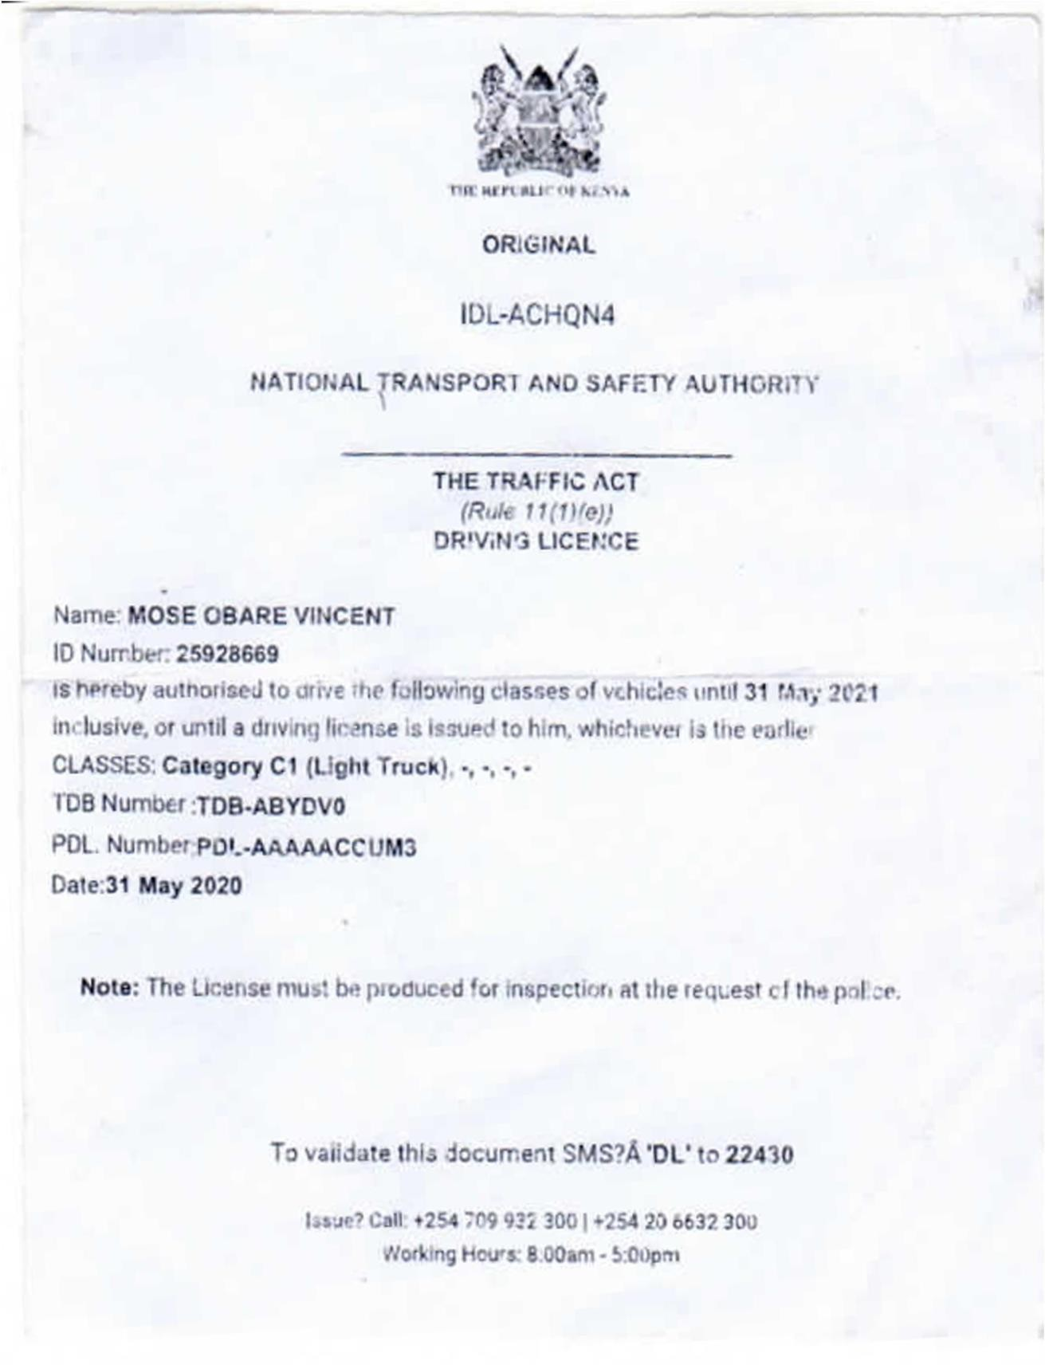

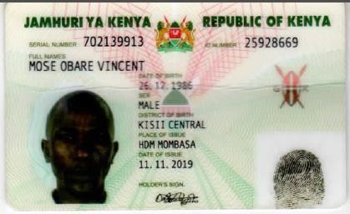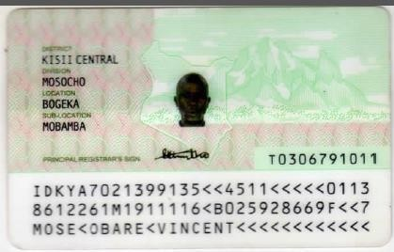

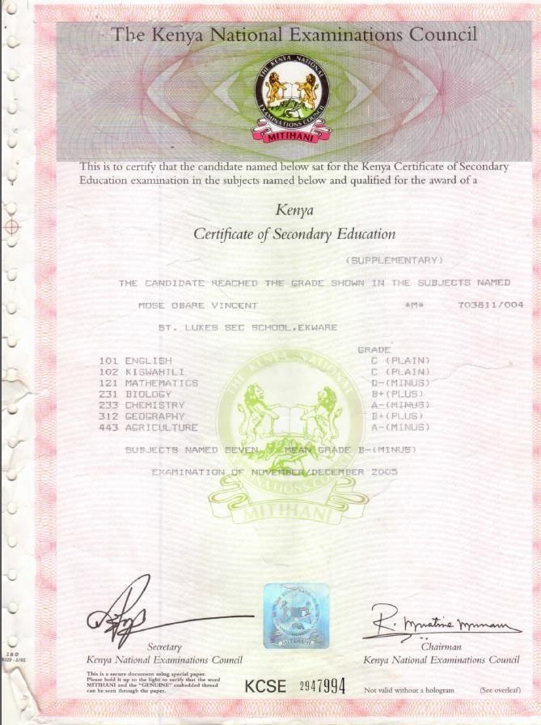

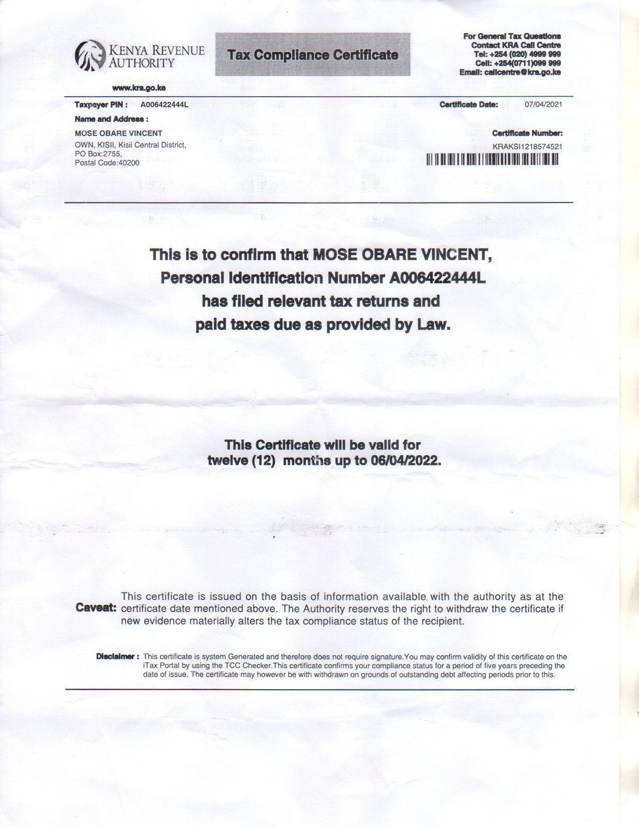

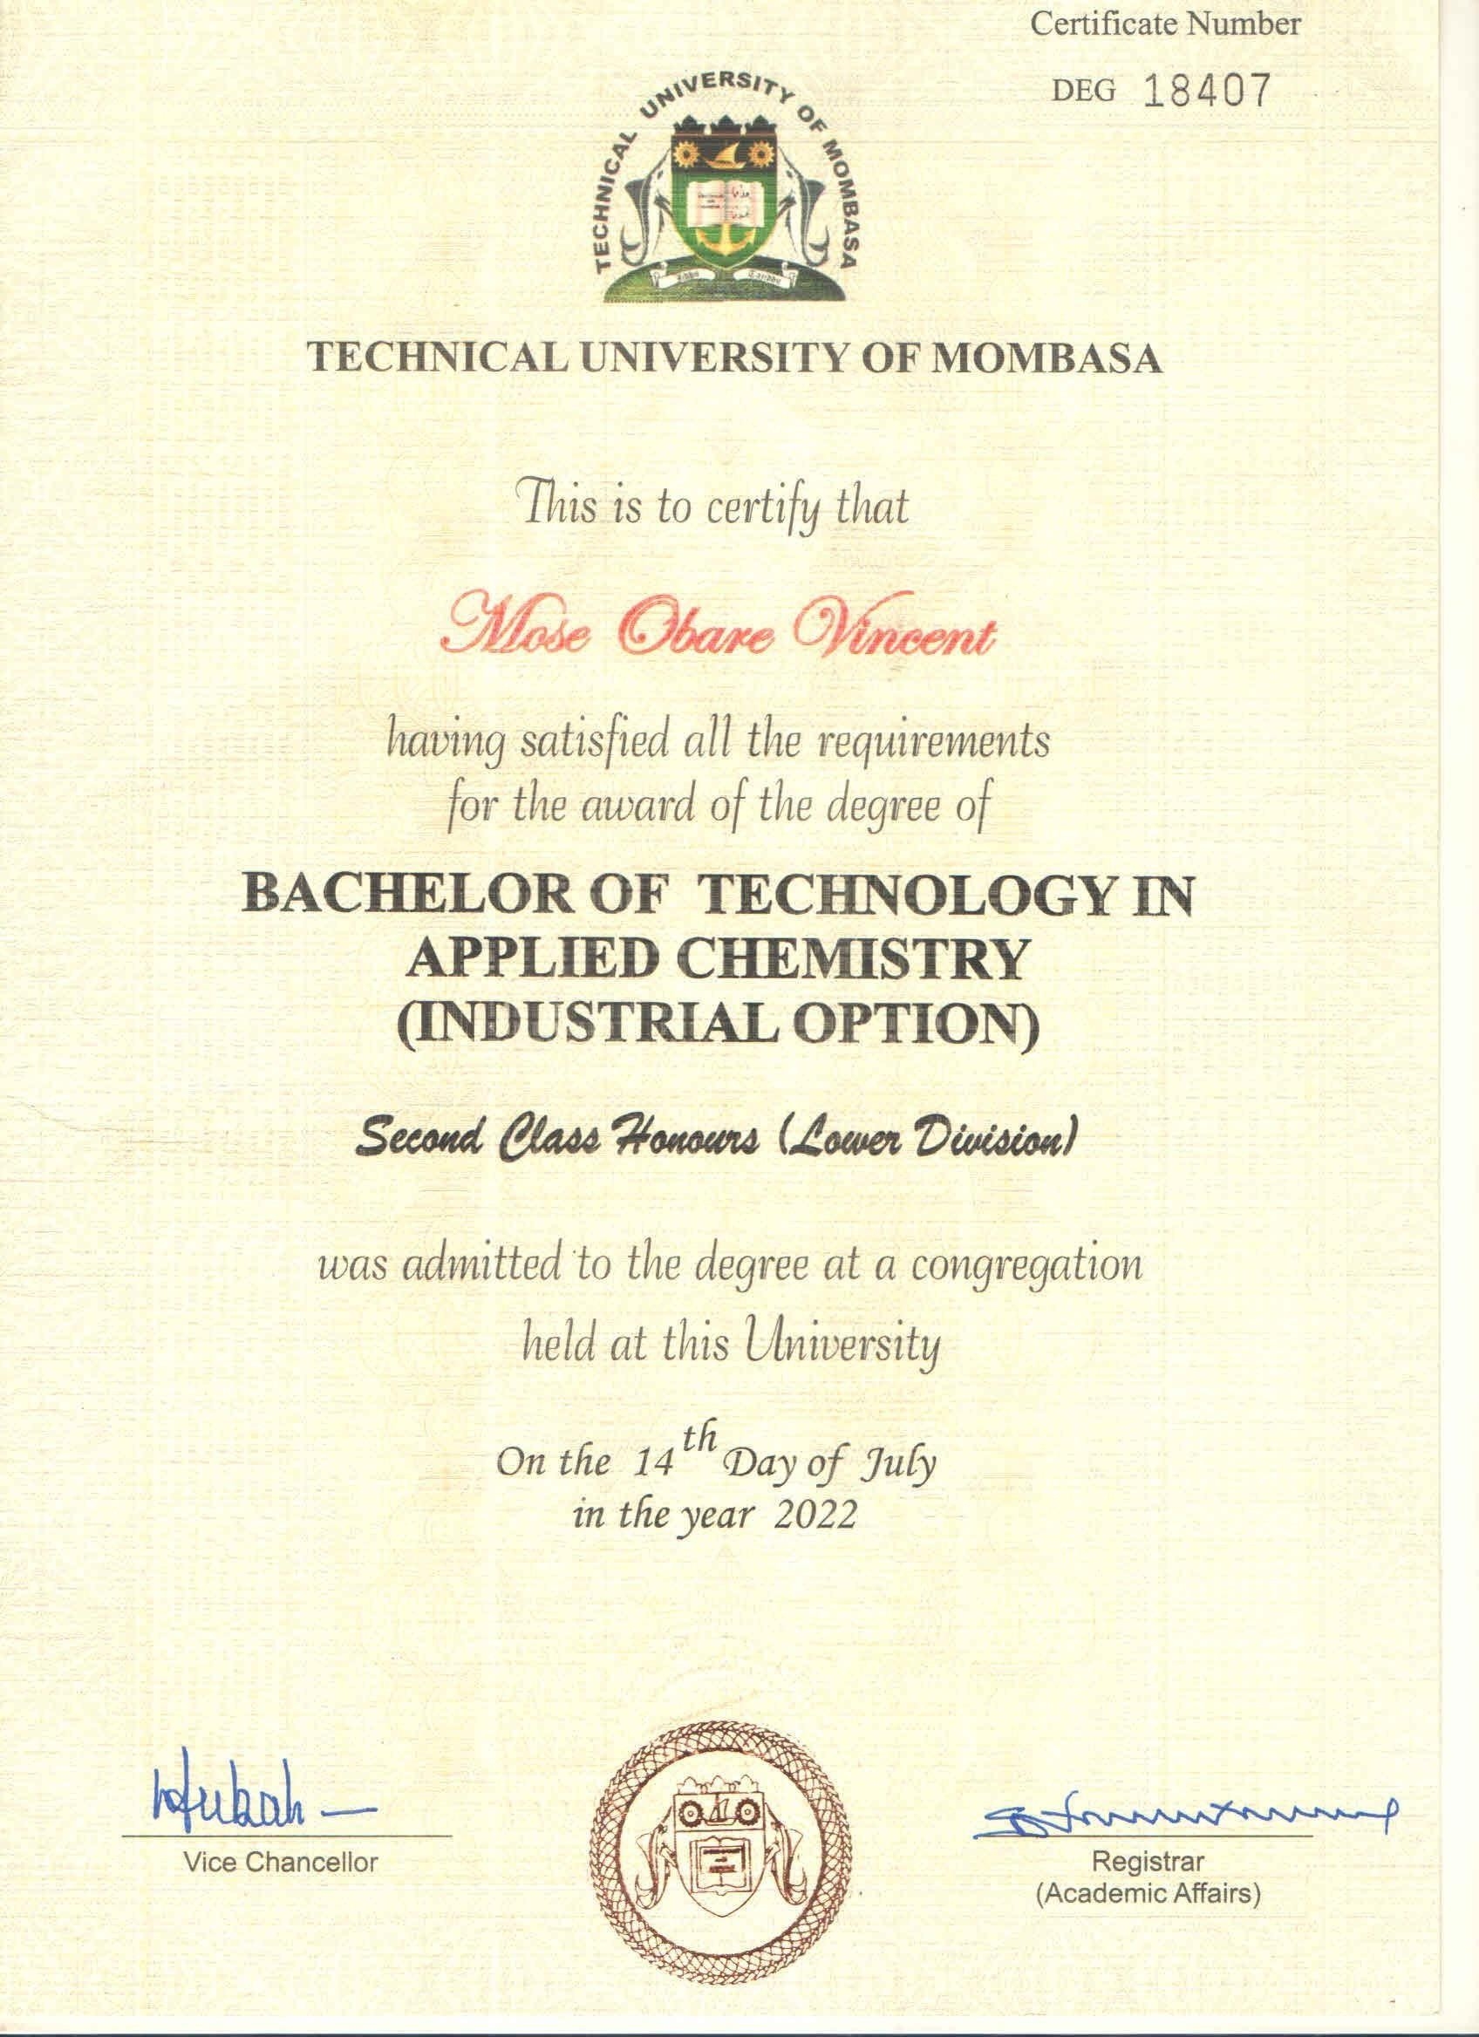

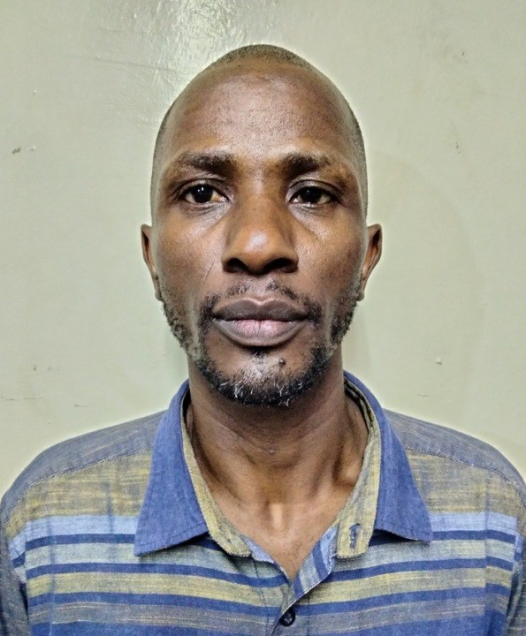
DRIVINGLICENCE
REPUBLICOFKENYA-JAMHURIYAKENYA
Surname
VINCENT
OtherNames
MOSEOBARE
DateofBirth
1978-10-16
Sex
Male
BloodGroup
UNKNOWN
NationalID No:
25928669
DrivingLicenceNo:
IDL-ACHQN4
Date of Issue/Renewal
31 May2020
DateofExpiry
11March2026
CATEGORIESOFVEHICLES DATEOFISSUE
DATEOFEXPIRY
LICENSINGOFFICER

ISSUEDBYNATIONAL TRANSPORTAND SAFETYAUTHORITY

