Amos Machira Ongau
1755_kisii
40200
0110517540 or 0725634736
machiraamos@gmail.com

Objective
Dedicated and passionate educator with a bachelor’s degree in education (ICT) from the University of Nairobi. Seeking a teaching position at New England Children Center to leverage my skills in technology integration and child development to create an engaging and supportive learning environment for children.

Education
Bachelor of Education (ICT)
University of Nairobi, Nairobi, Kenya
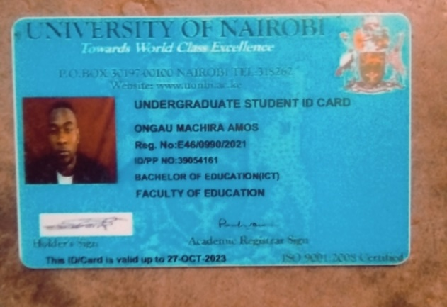
Professional Experience
ICT Teacher
[Rongai schools, kisii intern schools], [Nairobi ]
- Developed and implemented engaging lesson plans that integrate technology into the curriculum, enhancing students' learning experiences.
- Fostered a positive classroom environment that encourages student participation and collaboration.
- Utilized various teaching methods and resources to accommodate different learning styles and abilities.
- Conducted assessments to evaluate student progress and provided feedback to students and parents.
Student Teacher
[Gesiaga high school], [kisii]
[2024]
- Assisted lead teacher in planning and delivering lessons in ICT and other subjects.
- Supported students in their learning, providing one-on-one assistance and encouragement.
- Participated in parent-teacher conferences and school events to promote community involvement.

Skills
- Proficient in educational technology and software (e.g., Google Classroom, Microsoft Office Suite, educational apps).
- Strong communication and interpersonal skills, with the ability to build rapport with students, parents, and colleagues.
- Excellent organizational and time management abilities.
- Knowledge of child development principles and best practices in early childhood education.
- Ability to create inclusive lesson plans that cater to diverse learning needs.

Volunteer Experience
Volunteer Tutor
[car sell agency ict expert for cctv monitor], [Nairobi ]
[Month, Year] – [Month, Year]
- Provided tutoring support to underprivileged children in ICT and other subjects, helping to improve their academic performance.
- Organized educational workshops and activities to promote learning and engagement among students.

