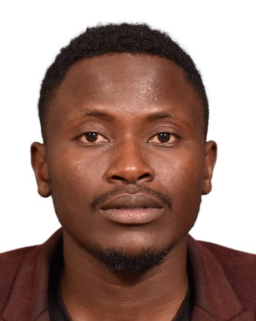
MUSA OJIAMBO
Musaojiambo14@gmail.com
+254 726361731/+966531970174
Riyadh, KSA.

PERSONAL SUMMARY
I am a Kenyan, I have basic computer knowledge in all the computer packages, such as Microsoft word, Excel and PowerPoint. I have worked as a Liaison Officer and also a licensed Driver with RMZ Recruitment Company in Riyadh, Kingdom of Saudi Arabia for 2 and a half years.

EDUCATION
Diploma in Information Technology
Mount Kenya University, Kenya.
Computer MS Basic Skills
Eldoret College of Professional Studies
WORK EXPERIENCE

Nation Media Group. Kenya
- Made job orders and placed information on sales and returns in DMS System.
- Monitored company cars on tracks during countrywide daily deliveries

RMZ RECRUITMENT COMPANY, Riyadh. KSA
- Creating contracts in Musaned for approval by external/foreign offices.
- Following up for contracts progress with external/foreign office until they are stamped.
- Picking applicants from the airport and deliver them to the employers’ destinations.
- Creating and Submission of FILIPINO contracts to MWO (Migrant Works Office) for approval.
- Following up for NO PENDING CASES for Filipino Candidate for whitelisting after every 6 months.
- Creating and Submission of documents for Accreditation i.e. Philippines, Kenya, Ethiopia, India, Thailand, Bangladesh, Sri Lanka, Indonesia and Uganda.

SKILLS
Corel Draw, Microsoft Word, Excel and Power Point and car driving.

REFERENCES
ABDULAZIZ NASSER ALSAIF
GENERAL MANAGER
RMZ RECRUITMENT COMPANY
Tel: +966 500872878

AHMED KAMAL
ACCOUNTANT
Tel; +966554726003

