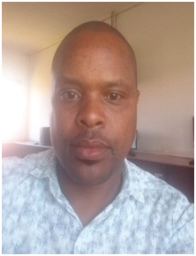

⇒ Bate of Birth :13/4/1986
⇒ Gender : Male
⇒ Nationality :Kenyan
⇒ Languages :English,Kiswahili,Kikuyu
⇒ Marital Status : Single
⇒ Email : karimigeorge94@gmail.com
⇒ Cell : 0726207593

PERSONAL DETAILS

EDUCATION BACKGROUND
2008-2009 College : Nyeri Technical Training Institute (Diploma in I..T)
2009-2010 College : Nyeri Technical Training Institute (Diploma in I..T)
2010 College : Nyeri Technical Training Institute (Diploma in I..T)

REFERENCES
Mathew
: 0754418401
WORK EXPERIENCE
Oct 2012 to Date Kagonye Boys I.T support

SECONDARY SCHOOL
2001-2005 Kirimara High School

Iam a Dependable individual with strong work ethics, exceptional ICT or any other assigned task with knowledge and problem solving skills seeking a position in your company, iam a quick learner self-motivated and diligent worker aiming to contribute to your organization goals.

PROFILE

