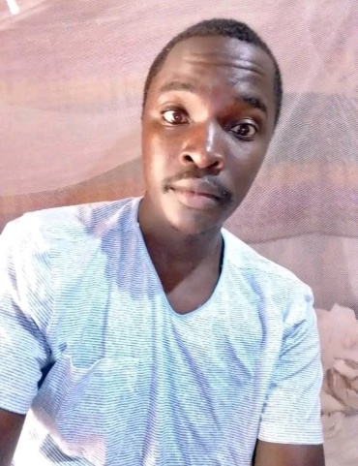

Education
2017 to 2020 : Sameta Boys High School Certificate of Secondary Education
2007-02016: Nyamage Primary School Kenya Certificate of Primary Education
Jun to Dec 2025: Imperial Driving School

Professional experience
2021 – 2022: Daylight Design and Graphics Company
- Proficient in database programs and Microsoft applications.
- Experience of working with computerized systems and ability to quickly learn new systems, processes/procedures and adapt local practices to global.
- Strong analytical, planning and organization skills.

2022- 2023: Cowboys Restaurant, Daraja Moja
- Excellent customer service and relationship management skills.
- Exceptional interpersonal and communication skills with excellent customer service and relationship management skills.

REFEREES

ISAAC MARUCHA ONCHURU; MANAGER , COWBOYS RESTAURANT
Tel: 0741418312

GEORGE FANELL; MANAGING DIRECTOR, COWBOYS RESTAURANT
Tel; +12144559054

hobbies
- Football
- Running
- Swimming
- Travelling

PROFILE Summary
I am a keen, hardworking, reliable and excellent time keeper. I am a bright and receptive person, able to communicate with people at all levels. I am good at working using my own initiative and I am flexible in my approach to work duties. I have a good sense of humor and a pleasant approach.

Contact
+254748843342
thomasonderi2022@gmailcom
KISII, KSI, Kenya

tHOMAS ONDERI

