


LUCAS OMOLLO OTIENO

C O N T A C T
+974 7447 6980
+254 112 624-382
Lucasotieno863@gmail.com

S K I L L S
- Excellent interpersonal, communication skills.
- Proficient in Culinary techniques
- Excellent customer service skills
- Excels in menu development
- Proficient in menu specials
- Able to multitask
- Team lerdership skills
- Problem solving abilities
- Strong organizational and time management skills
- Consistent in providing efficiency and quality at work
- Attentive to detail.
- Knowledge of food safety and hygiene

H O B B I E S
  - Socializing
  - Cooking
  - Reading
  - Travelling
  - Swimmimg

P R O F I L E
Dedicated and versatile culinary professional with a rich and diverse background in high-profile establishments, showcasing a proven track record of excellence. Adept at managing kitchen operations, implementing innovative menu concepts and fostering a collaborative environment. Recognized for creativity, precision and passion for delivering exceptional culinary experiences.

C A R E E R O B J E C T I V E
To positively apply knowledge and practical skills in an organization that demands professionalism, discipline, team work and commitment to achieve its co-operated goals while growing and refining my culinary skills.

E D U C A T I O N

Amboseli Institute of Hospitality 2013
Diploma in Food Production

Amboseli Institute of Hospitality 2012
Certificate in Food Production

Mawego technical Training Institute 2009 - 2011
Certificate in Food Production

jera High School 2014 - 2017
Kenya Certificate of Secondary Education

P R O F F E S I O N A L E X P E R I E N C E

Bonds Gardens Restaurant 2019 - 2021
Position Sous Chef

Duties Include:
- Managed kitchen operations, overseeing a team of chefs and ensuring smooth work flow.
- Developed and executed new menu items, incorporating
innovative culinary concepts
- Conducted regular training sessions to enhance kitchen staff’s skills and maintain high standards.

Achievements
- Introduced a weekly chef`s special, which contributed to a 20% increase in returning customers.
- Implemented cost saving measures, leading to a 10% reduction in overall food costs.

Stedmak Hotels & Gardens 2018 - 2019
Position Sous Chef
Duties Include:
- Coordinated kitchen activities, optimizing efficiency and reducing service time.
- Collaborated with the head chef in menu planning and seasonal offerings,
- Conducted regular inventory assessments and implemented measures to minimize waste.

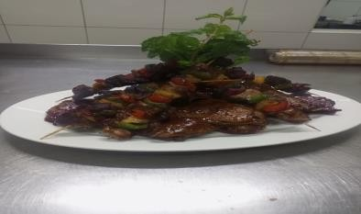
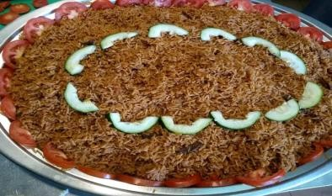
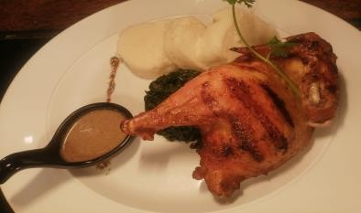
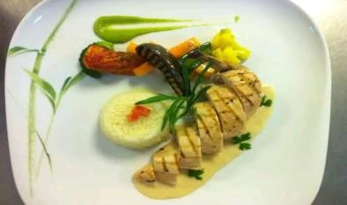
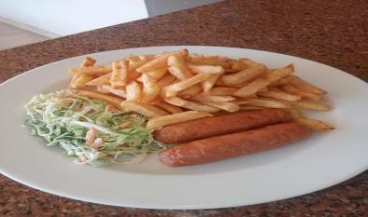
Zetech University 2016 - 2017

R E F E R E E S
- John Chege Chef
Fairmont the Norfolk Hotel John.chege@fairmount.com (+254) 720 534-507

- Timothy Makan Chef
Supreme Chefs Association (+254) 710 803-747

- Mrs. Helen Kibe Director
Amboseli Institute (+254) 722 347-205
Position Cook

Duties Include:
- Prepared and cooked a variety of dishes to cater diverse staff and student preferences.
- Collaborated with nutritionist to develop healthier menu options for the institution.
- Maintained a clean and organized kitchen environment, adhering to safety standards.

Fairmount the Norfolk 2015 - 2016
Position Casual Chef

Duties Include:
- Contributed to menu planning, emphasizing a fusion of local and international flavors.
- Ensured timely and high quality preparation of dishes.
- Trained junior kitchen staff in advanced culinary techniques, fostering skill development.

Serena Sweat Wayer`s Camp October – December 2013 Position Trainee Chef
Duties Include:
- Assisted in preparing safari-themed menus, considering unique logistical challenges.
- Maintained a flexible approach to accommodate dietary preferences of diverse guests.
- Collaborated with senior chefs in sourcing fresh, local ingredients for authentic flavors

680 Sentrim Tsavo October – December 2012 Position Cook
Duties Include:
- Managed cooking stations, ensuring efficient and organized meal preparation.
- Collaborated with colleagues to streamline inventory and reduce food wastage.
- Maintained a focus on quality control, consistently delivering well-presented dishes.

Lacio Regency Hotel April 2010 – July 2010 Position Trainee Chef
Duties Include:
- Participated in structured training programs, gaining exposure to various kitchen roles.
- Assisted in the preparations of complex dishes, learning under guidance of experienced chefs.
- Maintained a clean and organized workspace, adhering to high hygiene standards.

