CURRICULUM VITAE
NAME: WAMALWA NYONGESA IAN
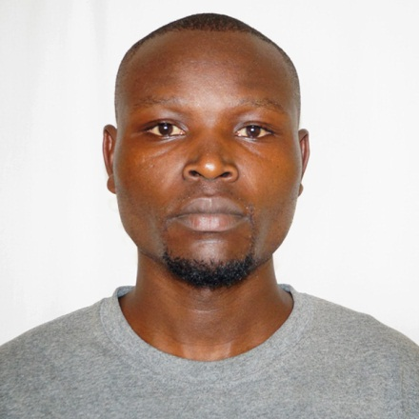

PERSONAL DETAIL
DATE OF BIRTH ……… 9th September 1999
GENDER ………. Male
NATIONALITY ………. Kenyan
LANGUAGE ……. English, Kiswahili & Mother tongue
PROFESSION ……. Production Engineer
MOBILE NO …….0768635597, 0782588107
E-mail address ……….wamalwaian@gmail.com

EDUCATION BACKGROUND
YEAR | STUDIES | CERTIFIED
2021-2024 | RIFT VALLEY TECHNICAL TRAINING INSTITUTE | DIPLOMA CERTIFICATE IN PRODUCTION ENGINEERING(ADVANCED)
2015-2018 | UMOJA SECONDARY SCHOOL | KCSE CERTIFICATE
2006-2014 | SOLO PRIMARY SCHOOL | KCPE CERTIFICATE

CAREER PROFILE
To serve effectively and have an atmosphere where I can contribute positively and grow professionally, I’m eager to apply my skills and learn rapidly implementing new skills and technology for the betterment of the organization, a team player for I can collaborate effectively and enhance team dynamics by communication. A part from being organized, I believe my strong background and the experience I have gained in my entire carrier makes me a great asset

MY KEY SKILLS AND PERSONAL ATTRIBUTE
• Organization: A highly organized individual who handles all tasks in methodical and timely manner. Efficient manages all resources and advices management on efficient utilization of energy.
• Interpersonal: Relates very well with people from different cultures and back grounds, able to work in multicultural environment.
• Report writing: competent in writing reports from the hands on job experience, I have responsibility for preparing reports on boiler and turbine performance and making recommendation over the same at appropriated time.

PAST WORK EXPERIENCE
EMPLOYER : Golden Africa Kenya Limited
POSITION : Attachment
DURATION : 05thseptember to December 22nd 2023
EMPLOYER : Eldo-Scrup Metal
POSITION : General worker
DURATION : 2024 August -2025

Responsibility;
- Utility Department Installation and repair of pumps and maintenance of boiler
- Oil filling Department Fitting and repair of oil filling equipment and its attachments.
- Power plant: Welding and repair of boiler accessories such as steam pipes by brazing
- Soap plant: installation and repair of pumps, valves and conduit system
- Refinery Department Installation and repair of pumps, heat exchangers, valves and conduit system
- E.T.P-Maintenance of the plant
- Machining and drilling operation.
- Blow-Molding and injection machine maintenance
- Maintenance of compressors and pneumatic systems
- Pressing bells from light scrup using a hydraulic press machine.
- Washing and separating different types of metals before loading
Main Responsibility
- Plant repair and maintenance
- Pumps installation
- Ability to detect plant failure
- Vibration control in plant
- Ability to do alignment
- Welding operations and brazing.
- Maintenance of injection and blow-molding molders
- Maintenance of pneumatic systems and air conditioners(compressors)
HOBBIES AND INTERESTS
- Creativity of new ideas
- Volunteer and Team work
- Carpentry
- Soccer fan
- Art and designing

REFEREES
1 Anthony Wamalwa
Boiler operator
WTS INTERNATIONAL CO.
Mobile phone 0720246744

2 Rotich Wesley
Supervisor Mechanical technician
Golden Africa (K) ltd
Mobile phone 0780554062
3 Micah Kamau Mwangi
Manager
Eldo-scrup metal co ltd
Mobile Phone 0769022943

