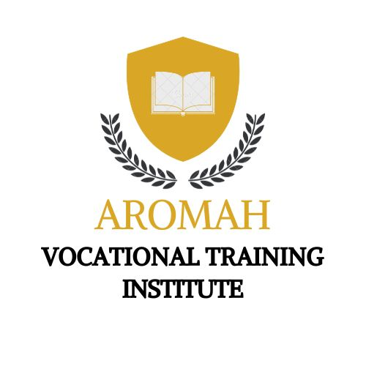
AROMAH VOCATIONAL AND TRAINING INSTITUTE
Course Outline:
- Roles and Responsibilities of the Nursing Assistant
- Communication and Documentation
- Safety, Standard Precautions, and Infection Control
- Admission, Transfer and Discharge
- Body System review, common disease and malformations
- Vital signs
Activities
- Normal Elimination Assistance
- Oral and Denture Care
- Hair/ Nail Care
- Skin Care
- Bathing Assistance
- Personal Care Assistance
- Shaving Assistance
- Dressing and Undressing Assistance
- Anti-Embolic stockings
- Bed making
- Nutritional / Fluid balance Assistance
- Special diet Assistance
- Mobility and ambulation Assistance

