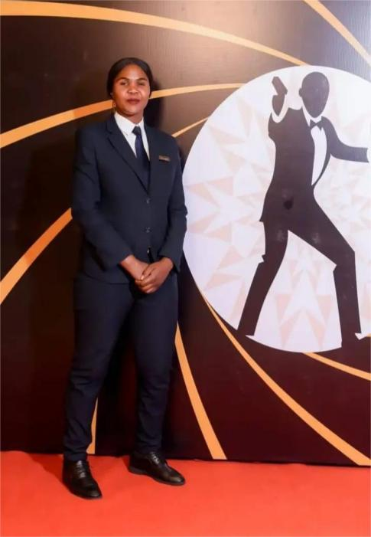 |  | SAsha miriam ratemo  Security Officer
Contact  PHONE:  +254711448199  +254703839360  EMAIL:  sashamoraa@gmail.com |  | Professional Summary  Highly dedicated and result-oriented seeking a challenging environment that demands continuous improvement, dedication, creativity and sound decision making. Proven team player with unquestionable integrity and high initiative, capable of working independently with minimum supervision. Offers a unique combination of security experience strong analytical skills and adaptability to new working environment.  competence  • Good inter-personal skills  • Formulate sound internal policies and procedures  • Result oriented  • Strong analytical skills  • High integrity and capable of working independently  • Fast learner able to adapt to new working environment  professional experience  Security officer  Moyo Casino  Employed 2023 – Present  - Maintain vigilance and order on incoming clients and staff members  - Responsible in-monitoring and patrol assigned areas to prevent and detect signs of intrusion, ensuring the safety of personnel and property.  - Prepare comprehensive incident reports and daily activity logs for management review.  - Offer safety warning to maintain a secure environment  - Conduct regular safety inspections and enforce compliance with security protocols and emergency plans  - Respond promptly to alarms and investigate disturbances, coordinating with local law enforcement as needed.  - Perform any other assigned duties  qualification  Technical Certification Skills  • Qualified First aid Certification  • Qualified Fire-fighter Certification  education  Certifications  • Magena High School KCSE Certificate  • Nyantira Primary School KCPE Certificate  referral  Referees:  Mr. Macklay Sanaya  Great-wall Residence  Cell 0729088825  Mr. Rowland Nyagah  Online Courier services  Cell. 0723995069  Mr. Collins Ombisa  The Reef Hotel  Cell. +974 74059411  Mr. Cax

