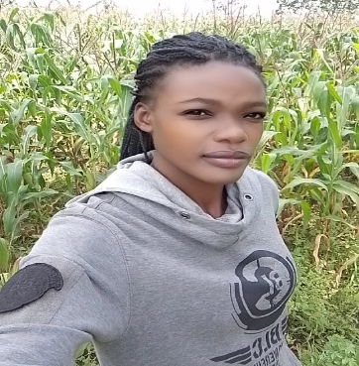
CAREN NYONGESA
Agriculturalist
Address: P.O Box 190-50100 Kakamega · Phone: +254715159603
Email · carennamarome288@gmail.com

A passionate and skilled famer in organic and Agro ecological agriculture with practical experiences on various soil types as well as guiding small holder farmers around Kakamega region. I strongly believe that the key solution to food security is sustainable agriculture.

Experience
12/5/2025 - 1/8/2025. Worked as an intern at Bio-Vision Africa Trust Kakamega farmer's resource center .
2019 - 2021.worked on my leased farms before joining college to gain more knowledge on farming practices.

Education
DIPLOMA IN GENERAL AGRICULTURE
MASINDE MULIRO UNIVERSITY - KAKAMEGA 2022- 2025

ACHIEVEMENTS
12/5/2025- 1/8/2025 worked as an attaché at Bio - vision Africa Trust Kakamega farmer's resource center and successfully attained the skills on agroecological agriculture. | 21/10/2024 - 25/10/2014- completed a regenerative agriculture course at TAMALU farm Laikipia

skills
TECHNICAL SKILLS
- Microsoft excel
- Soil health principles
- Agro ecological principles
- Crop protection skills
- Animal management principles and practices.
SOFT SKILLS
- -Analytical thinking
- - Problem solving
- - Communication skills
LANGUAGES
- - English
- - Kiswahili
- - Luo
- - Luyha
HOBBIES
- - Farming
- - Traveling
- - Bike riding

