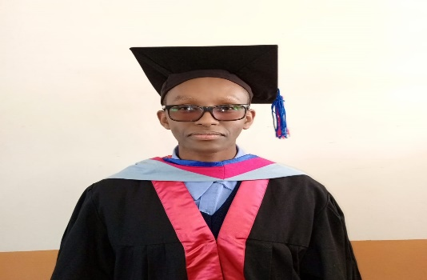
Curriculum vitae
personal data
surname: ndiira
first name: mathew
ADDRESS: P.O BOX 32 NJORO
TELEPHONE: +254796438907| +254793669721 |+237656236506.
EMAIL ADDRESS: mathewndiira7@gmail.com\Mathewndiira10@gmail.com.
citizenship: Kenyan
languages: both written and spoken, English, French AND KISWAHILI.
marital status: single
date of birth 7thJune 1997
NATIONALITY: KENYAN
CAREERER OBJECTIVE
Highly motivated, Hardworking, Resilient, creative, innovative and simple person.

Academic, Professional Qualifications and Work experience.

2024-2025: Worked in Oblates of Mary Immaculate Cameroon Province Yaounde.
2021-2023: Consolata Institute of Philosophy Langata.

- Diploma of Philosophy Pontifical Urbaniana Rome.
- Diploma of Religious Study Pontifical Urbaniana Rome.
-Bachelor of Philosophy Pontifical Urbaniana Rome.
-Bachelor of Philosophy Catholic University of Eastern Africa, Langata-Nairobi.

2018- 2020: Receptionist St. Clare Health Centre, Elburgon.
2017-2018: St. Clare Complex, Computer packages, best student, awarded certificate Elburgon.
2012-2015: St. Peters Elburgon Secondary School. KCSE- Certificate mean grade C+.
2003-2011: Kenana Primary School, KCPE- Certificate mean grade C+.

